WEEK 3
Spring Core and Maven, Spring Data JPA with Spring Boot, Hibernate

Spring Core and Maven
- Configuring a Basic Spring Application:

Create a Maven Project LMS

Add Spring Dependency in Pom.xml:
<dependency>
<groupId>org.springframework</groupId>
<artifactId>spring-context</artifactId>
</dependency>

Create applicationContext.xml:
<?xml version="1.0" encoding="UTF-8"?>
<beans xmlns="http://www.springframework.org/schema/beans"
xmlns:xsi="http://www.w3.org/2001/XMLSchema-instance"
xsi:schemaLocation="http://www.springframework.org/schema/beans
http://www.springframework.org/schema/beans/spring-beans.xsd">

<bean id="bookRepository" class="com.cognizant.lms.repo.BookRepository" />

<bean id="bookService" class="com.cognizant.lms.service.BookService">
<property name="bookRepository" ref="bookRepository" />
</bean>
</beans>

Create BookRepository.java:
package com.cognizant.lms.repo;

public class BookRepository {
public void saveBook(String bookName) {
System.out.println("Book '" + bookName + "' saved to the repository.");
}
}

Create BookService.java:
package com.cognizant.lms.service;

import com.cognizant.lms.repo.BookRepository;

public class BookService {
private BookRepository bookRepository;

// Setter for dependency injection
public void setBookRepository(BookRepository bookRepository) {
this.bookRepository = bookRepository;
}

public void addBook(String bookName) {
System.out.println("Adding book: " + bookName);
bookRepository.saveBook(bookName);
}
}

Create App.java:
package com.cognizant.lms;

import org.springframework.context.ApplicationContext;
import org.springframework.context.support.ClassPathXmlApplicationContext;

import com.cognizant.lms.service.BookService;

public class App {
public static void main(String[] args) {
ApplicationContext context = new ClassPathXmlApplicationContext("applicationContext.xml");

BookService bookService = (BookService) context.getBean("bookService");
bookService.addBook("Spring in Action");
}
}

Output:
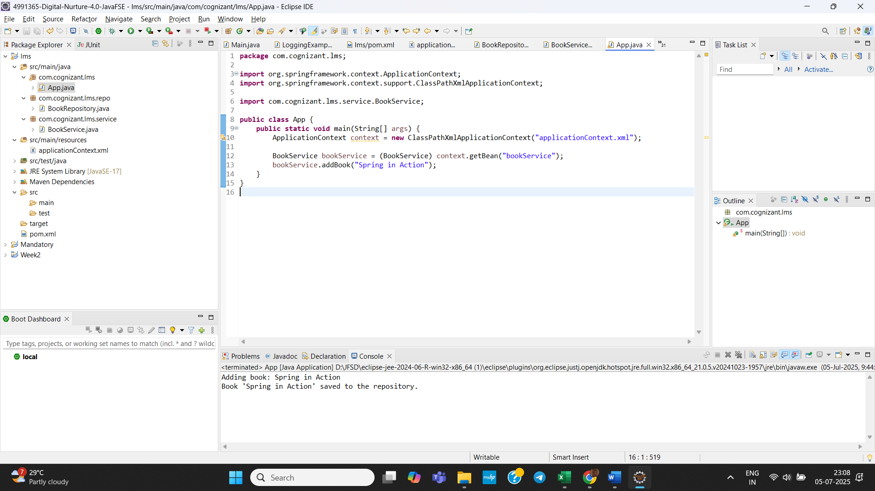

- Implementing Dependency Injection:

Create a Maven Project LMS

Add Spring Dependency in Pom.xml:
<dependency>
<groupId>org.springframework</groupId>
<artifactId>spring-context</artifactId>
</dependency>

Create applicationContext.xml:
<?xml version="1.0" encoding="UTF-8"?>
<beans xmlns="http://www.springframework.org/schema/beans"
xmlns:xsi="http://www.w3.org/2001/XMLSchema-instance"
xsi:schemaLocation="
http://www.springframework.org/schema/beans
http://www.springframework.org/schema/beans/spring-beans.xsd">

<!-- BookRepository Bean -->
<bean id="bookRepository" class="com.cognizant.lms.repo.BookRepository" />

<!-- BookService Bean with Dependency Injection -->
<bean id="bookService" class="com.cognizant.lms.service.BookService">
<property name="bookRepository" ref="bookRepository" />
</bean>

</beans>

Create BookRepository.java:
package com.cognizant.lms.repo;

public class BookRepository {
public void saveBook(String bookName) {
System.out.println("Book '" + bookName + "' saved to the repository.");
}
}

Create BookService.java:
package com.cognizant.lms.service;

import com.cognizant.lms.repo.BookRepository;

public class BookService {

private BookRepository bookRepository;

// Setter for Dependency Injection
public void setBookRepository(BookRepository bookRepository) {
this.bookRepository = bookRepository;
}

public void addBook(String bookName) {
System.out.println("BookService: Adding book: " + bookName);
bookRepository.saveBook(bookName);
}
}

Create App.java:
package com.cognizant.lms;

import org.springframework.context.ApplicationContext;
import org.springframework.context.support.ClassPathXmlApplicationContext;

import com.cognizant.lms.service.BookService;

public class App {
public static void main(String[] args) {
ApplicationContext context = new ClassPathXmlApplicationContext("applicationContext.xml");

BookService bookService = (BookService) context.getBean("bookService");
bookService.addBook("Spring in Action");
}
}

Output:
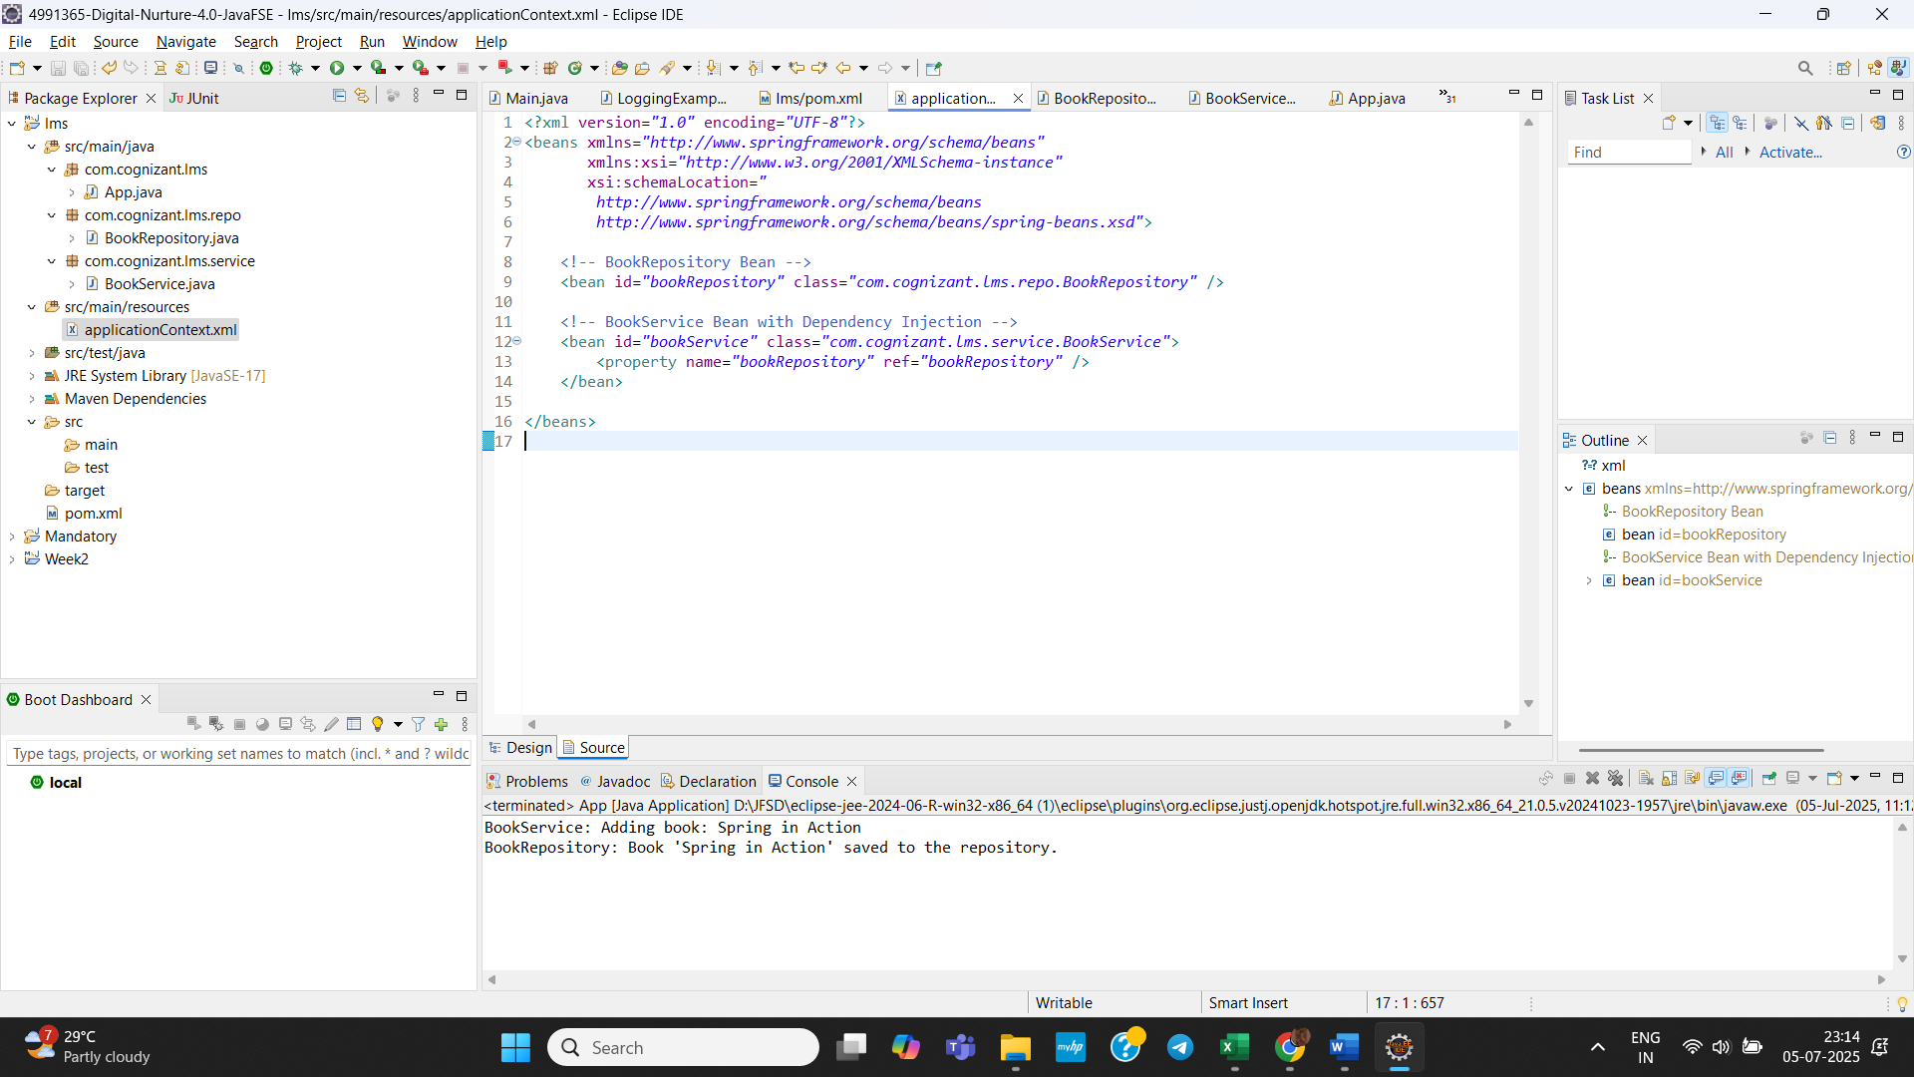

- Creating and Configuring a Maven Project

Create a maven project Library Management.

Add Spring Dependencies in Pom.xml :
<dependency>
<groupId>org.springframework</groupId>
<artifactId>spring-context</artifactId>
<version>5.3.32</version>
</dependency>

<!-- Spring AOP -->
<dependency>
<groupId>org.springframework</groupId>
<artifactId>spring-aop</artifactId>
<version>5.3.32</version>
</dependency>

<!-- Spring Web MVC -->
<dependency>
<groupId>org.springframework</groupId>
<artifactId>spring-webmvc</artifactId>
<version>5.3.32</version>
</dependency>

<!-- Servlet API (provided by container like Tomcat) -->
<dependency>
<groupId>javax.servlet</groupId>
<artifactId>javax.servlet-api</artifactId>
<version>4.0.1</version>
<scope>provided</scope>
</dependency>

Configure Maven Compiler Plugin:
<plugin>
<artifactId>maven-compiler-plugin</artifactId>
<version>3.10.1</version>
<configuration>
<source>1.8</source>
<target>1.8</target>
</configuration>
</plugin>

Output:
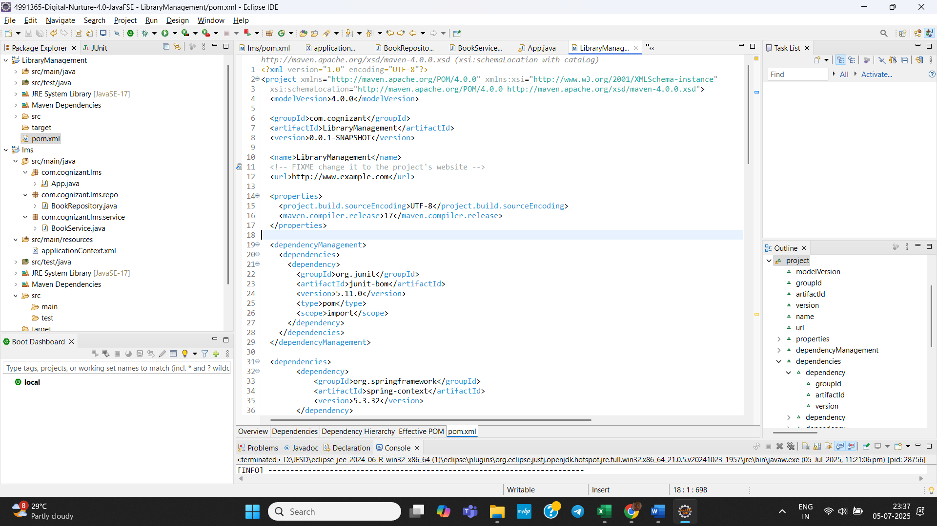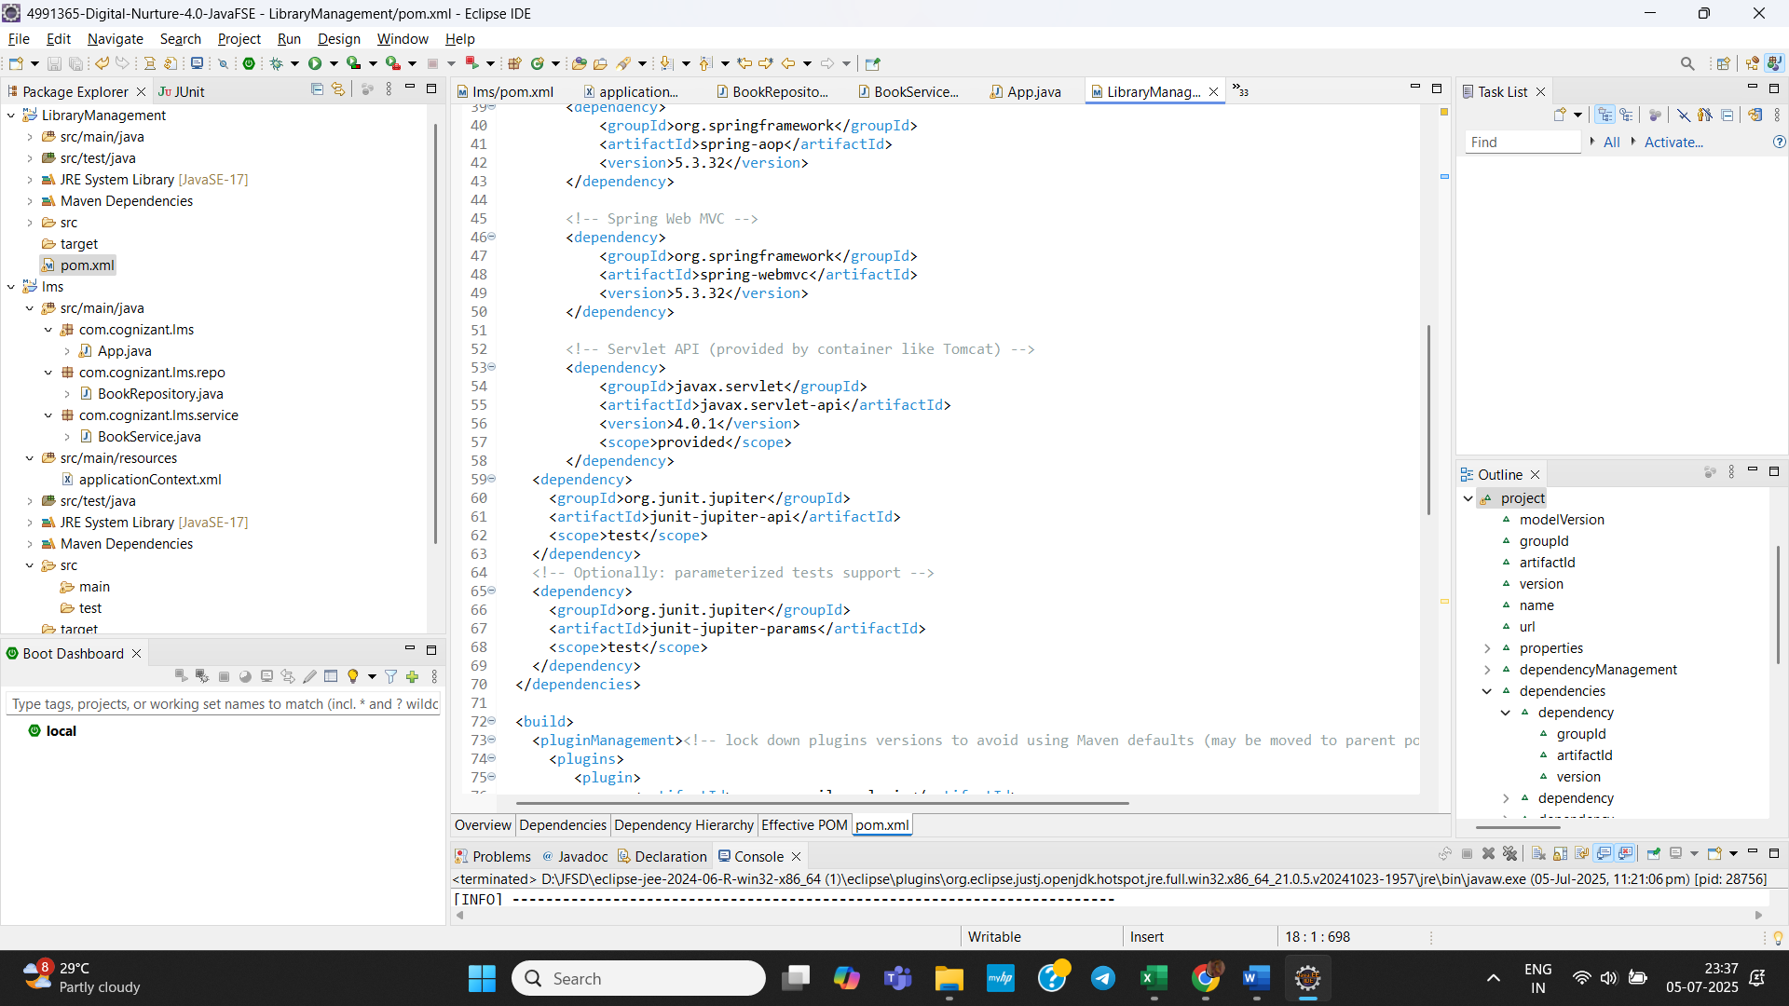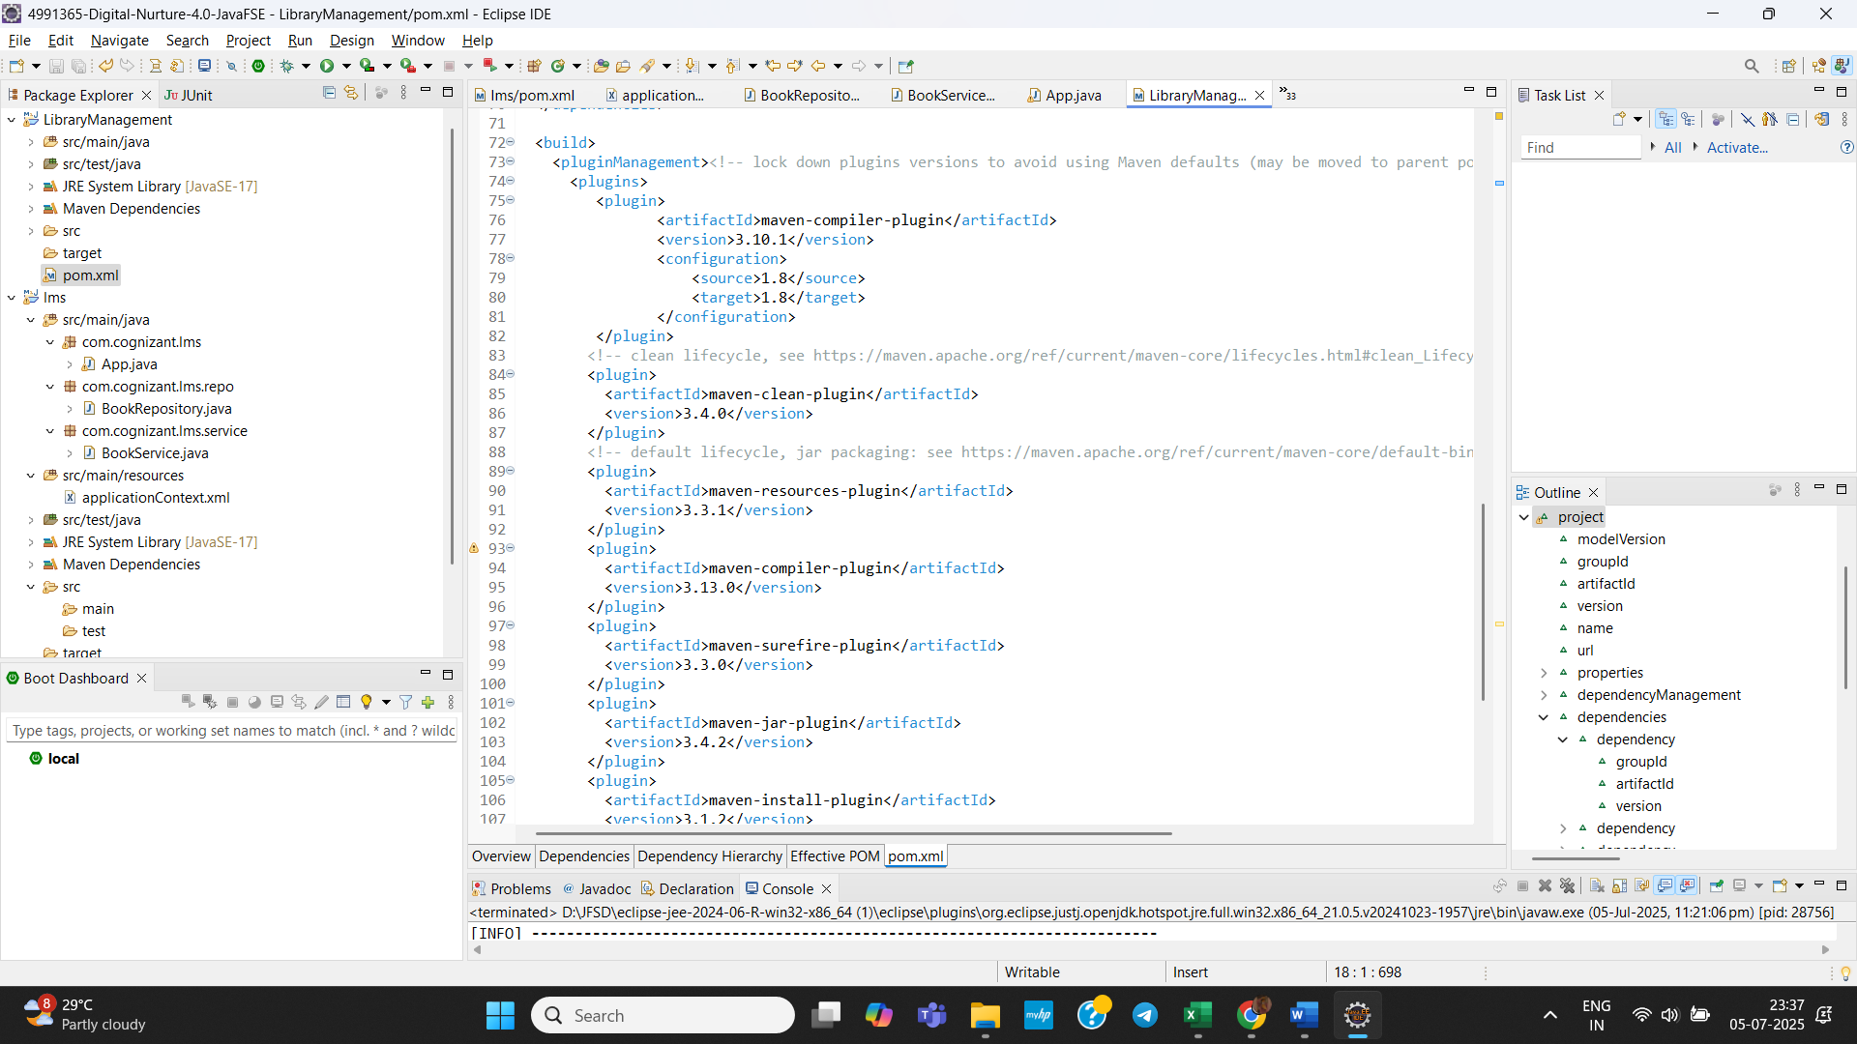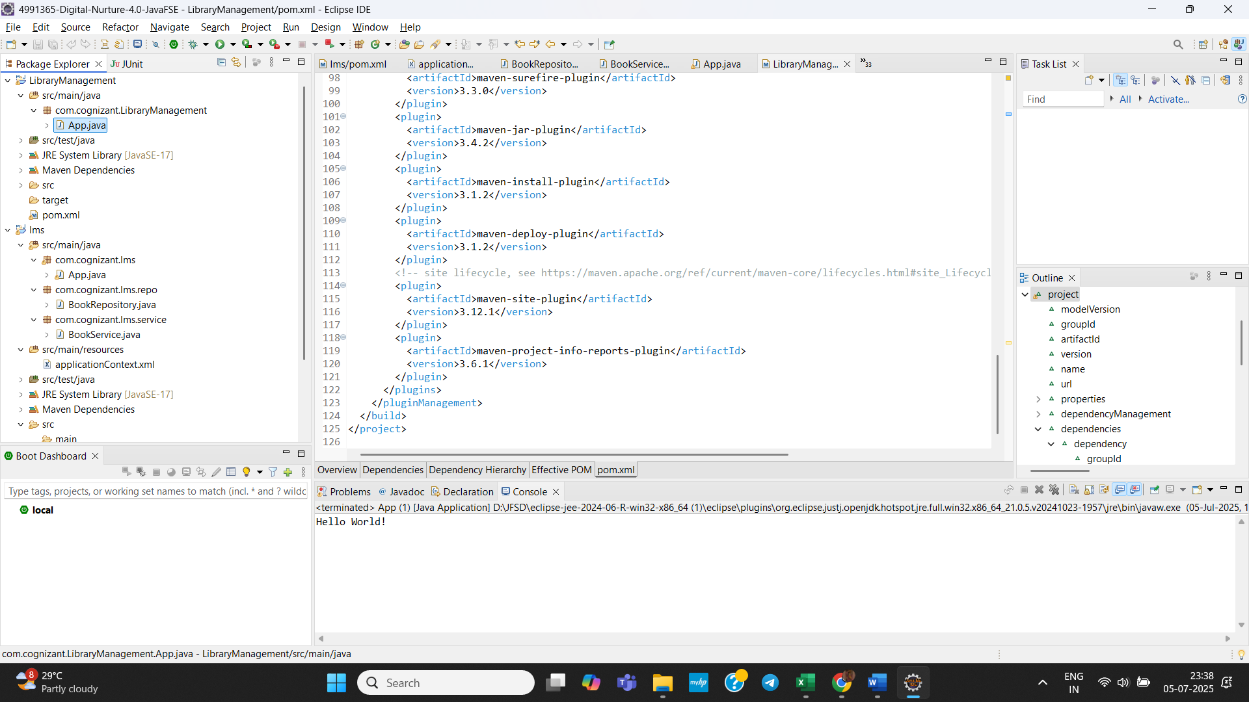

Spring Data JPA with Spring Boot, Hibernate

- Spring Data JPA - Quick Example:
Execution:
Steps :-
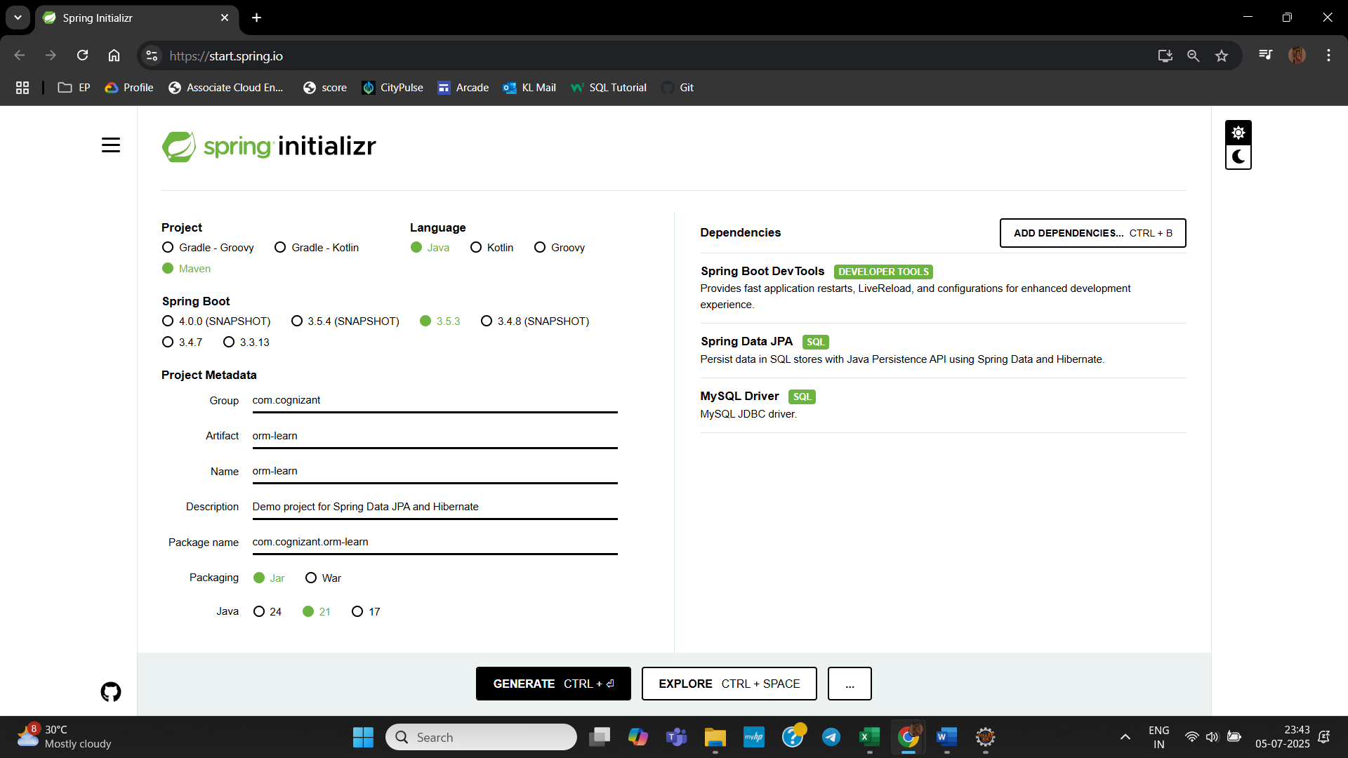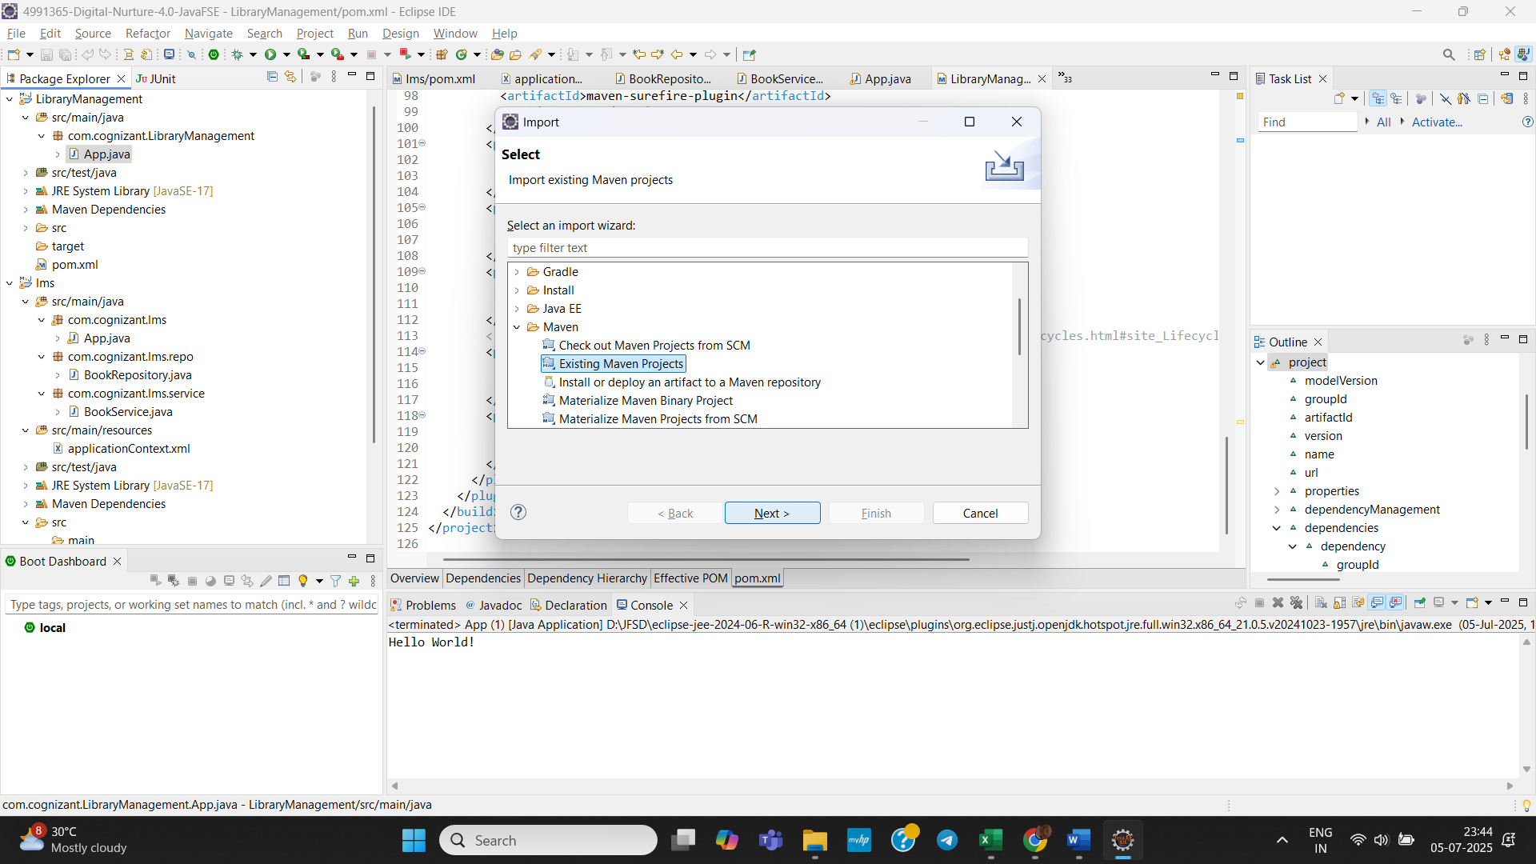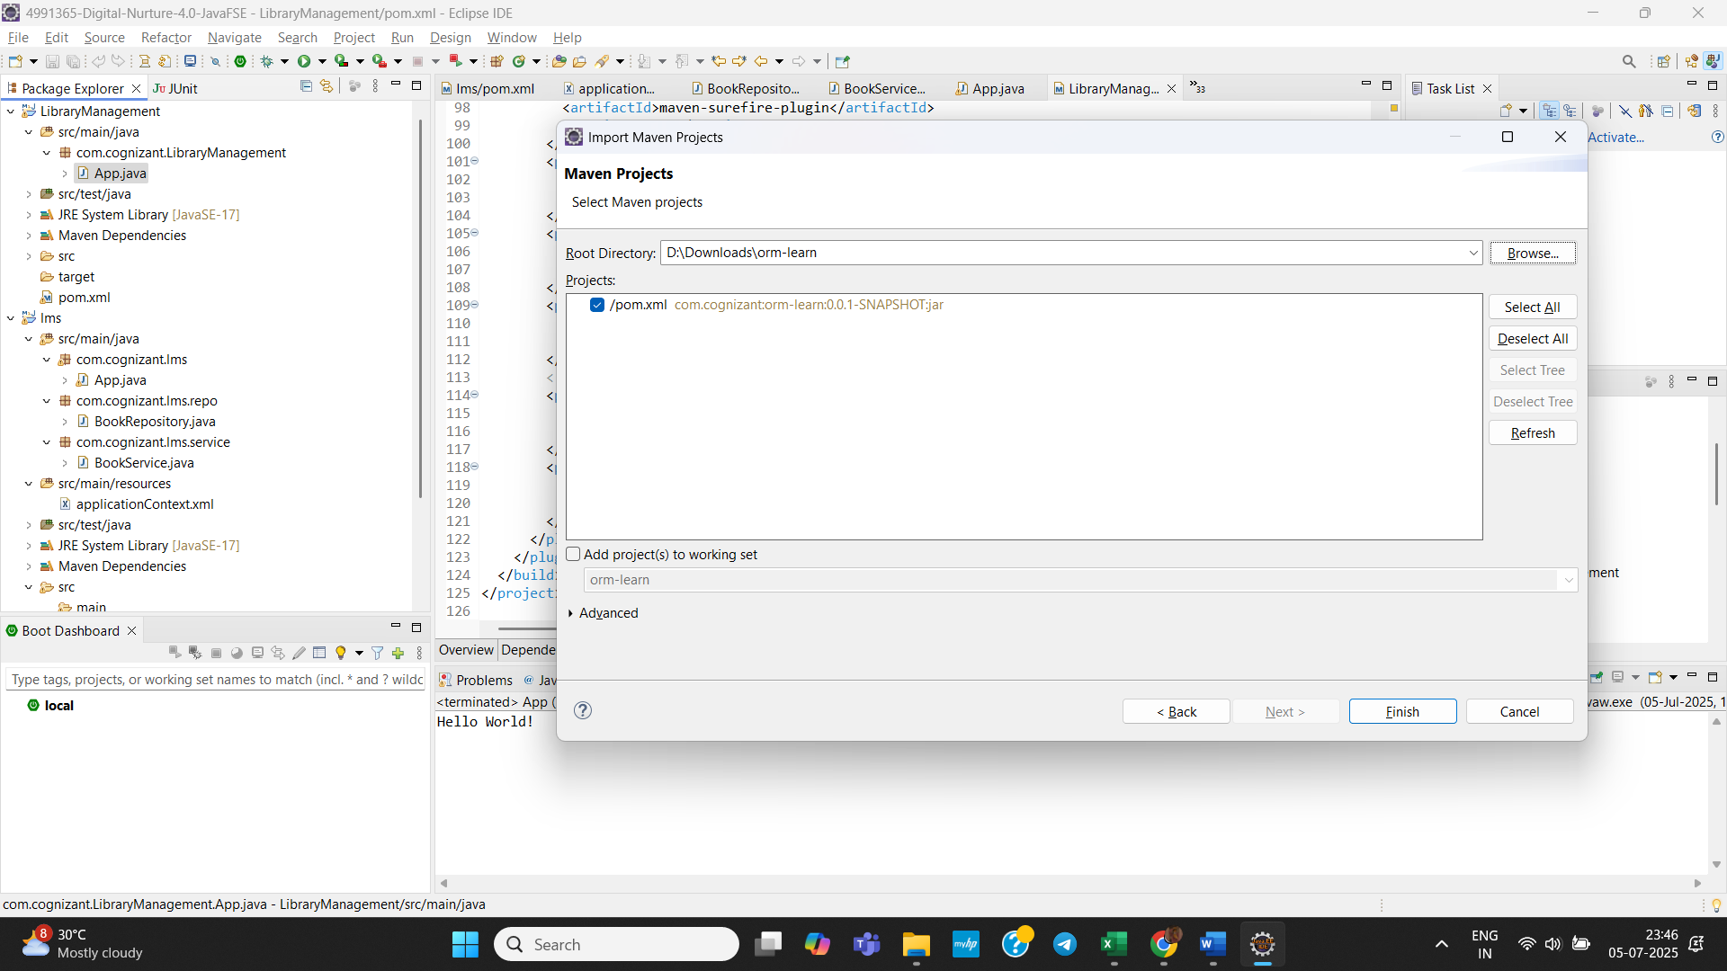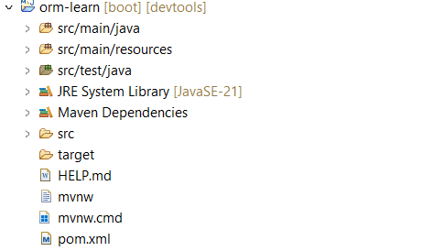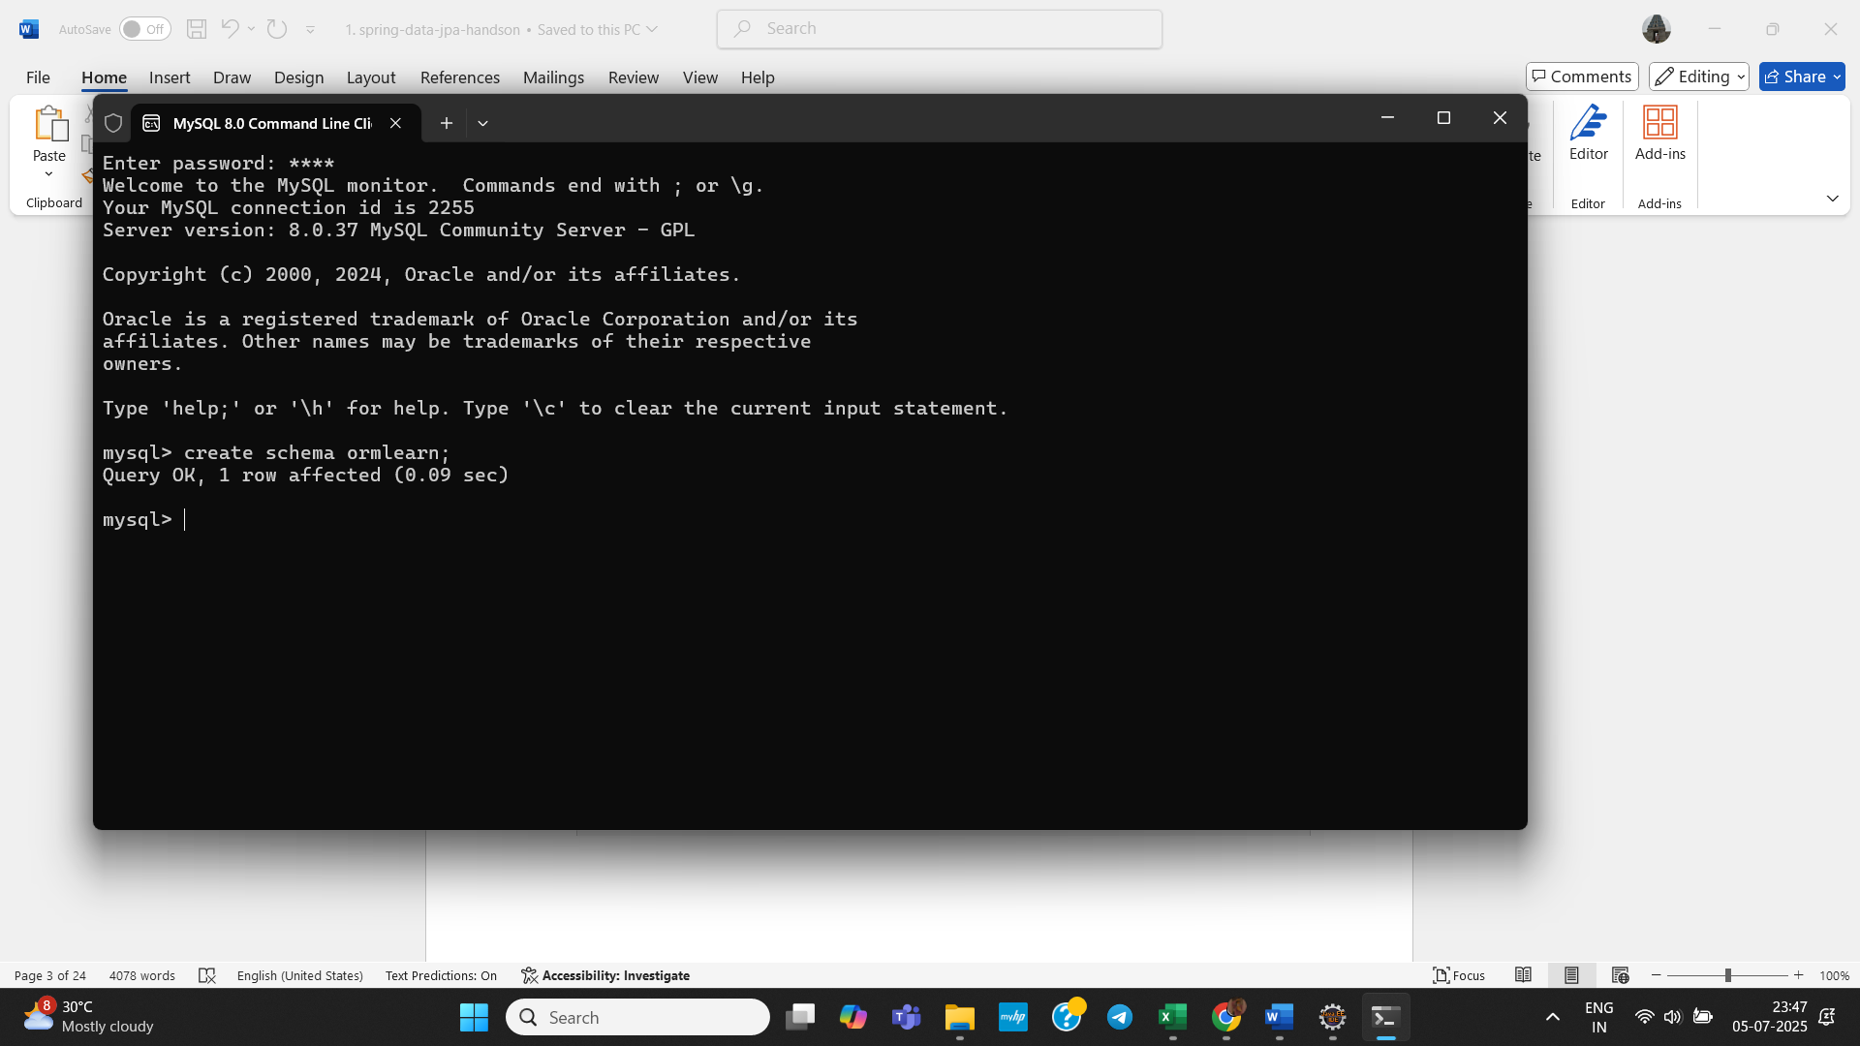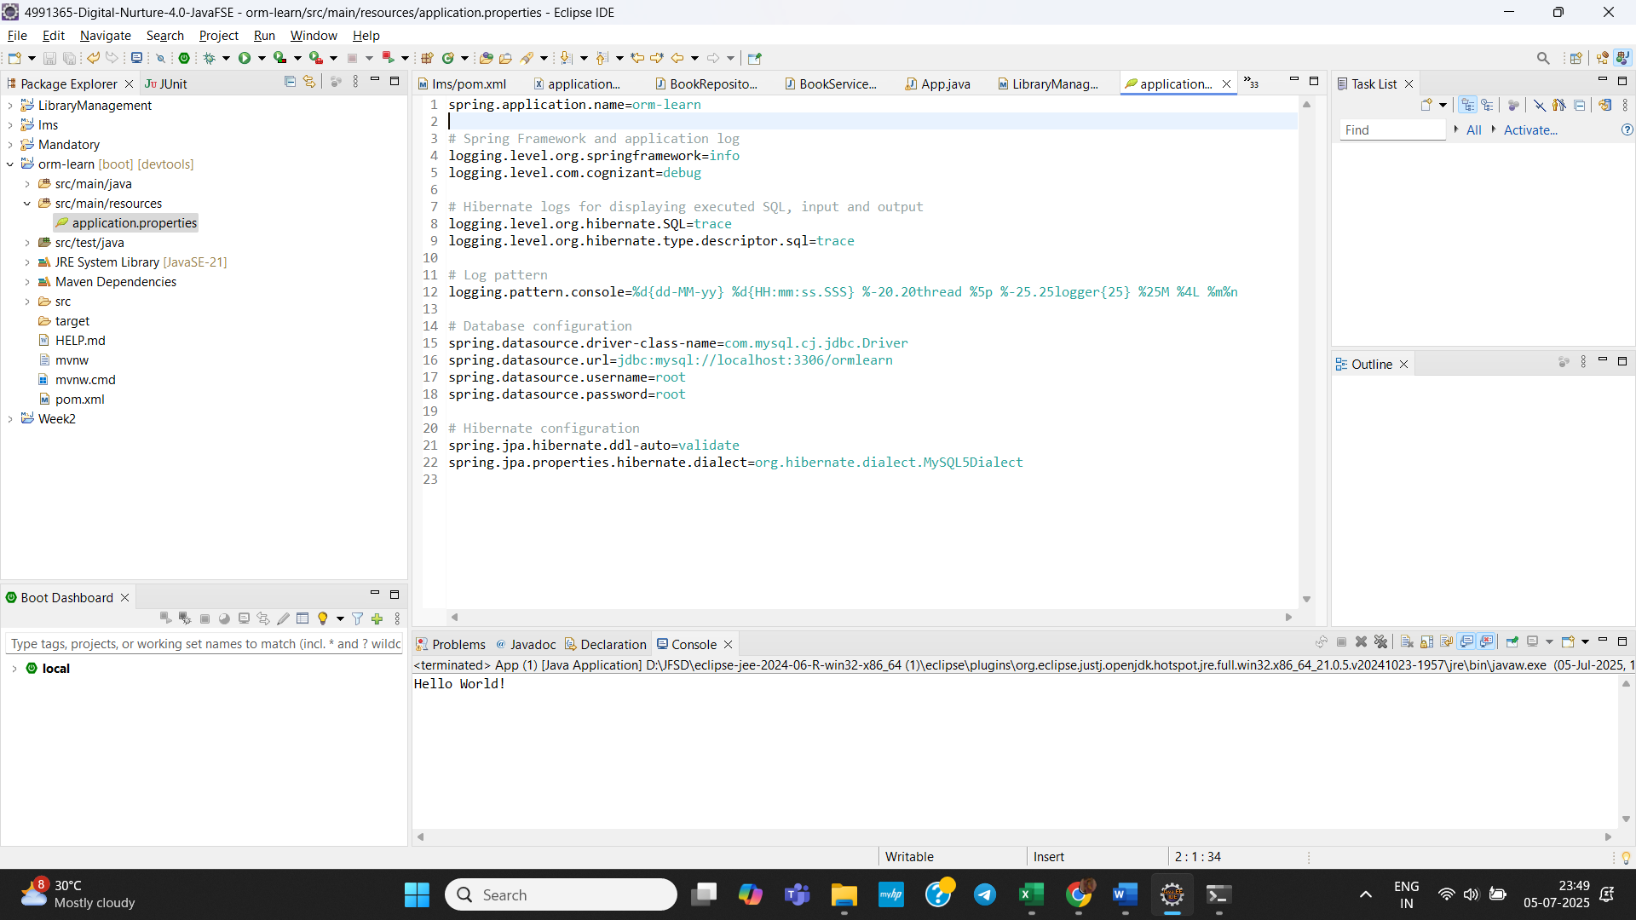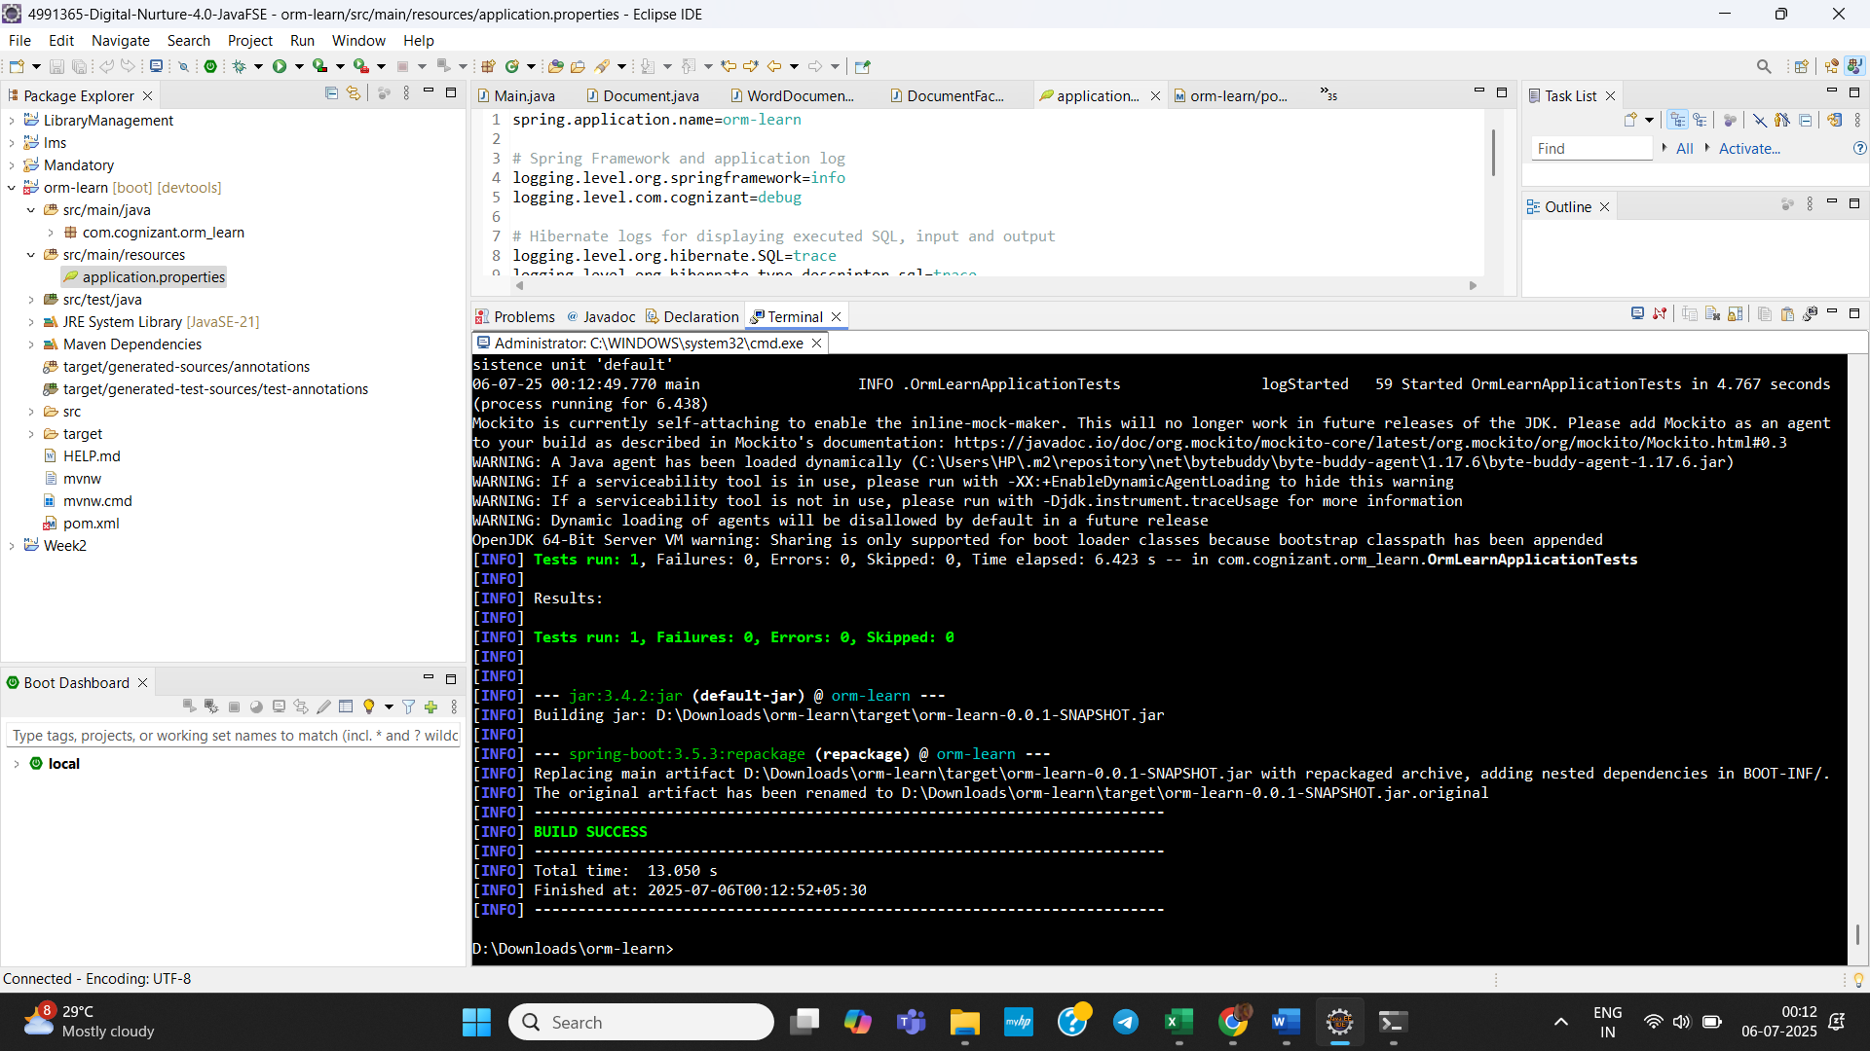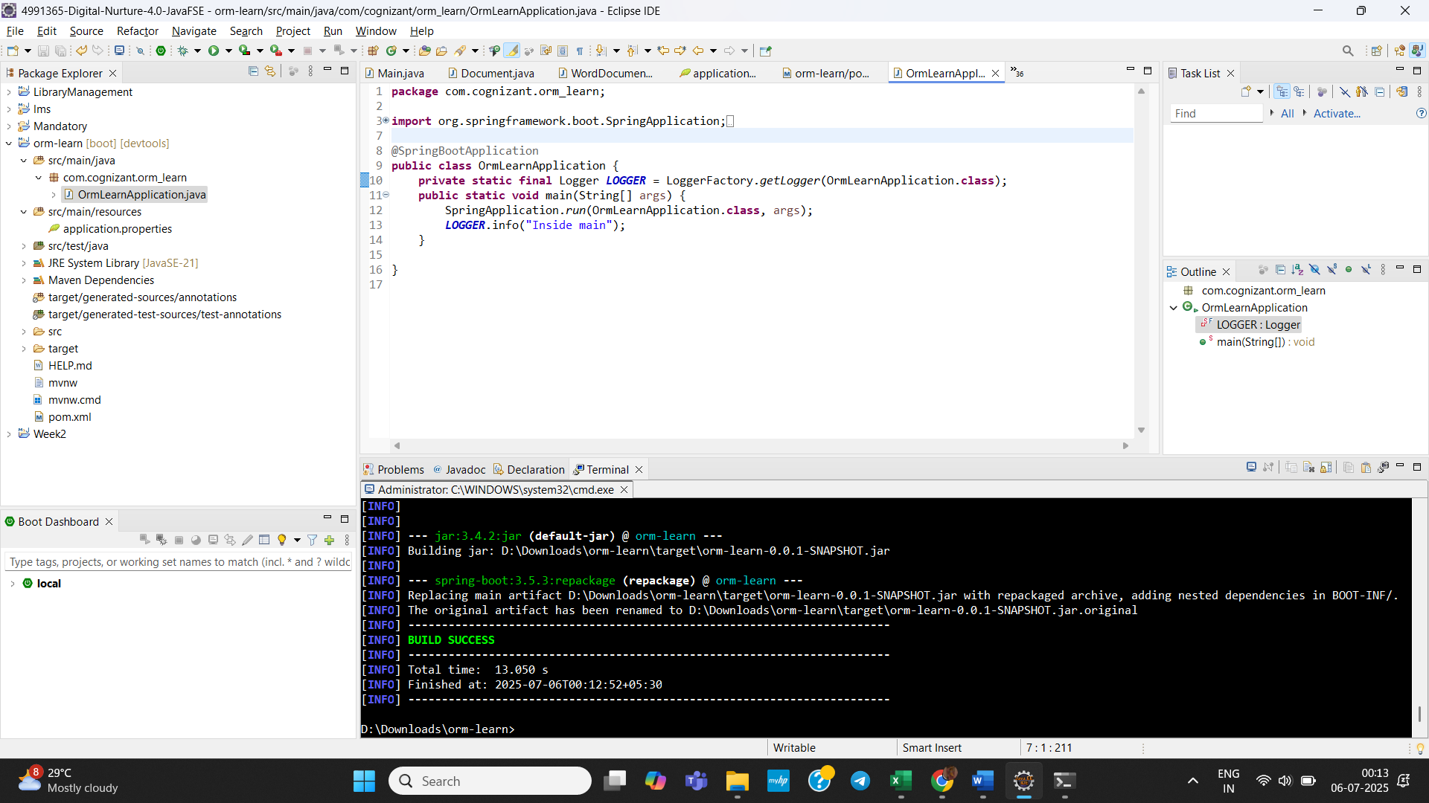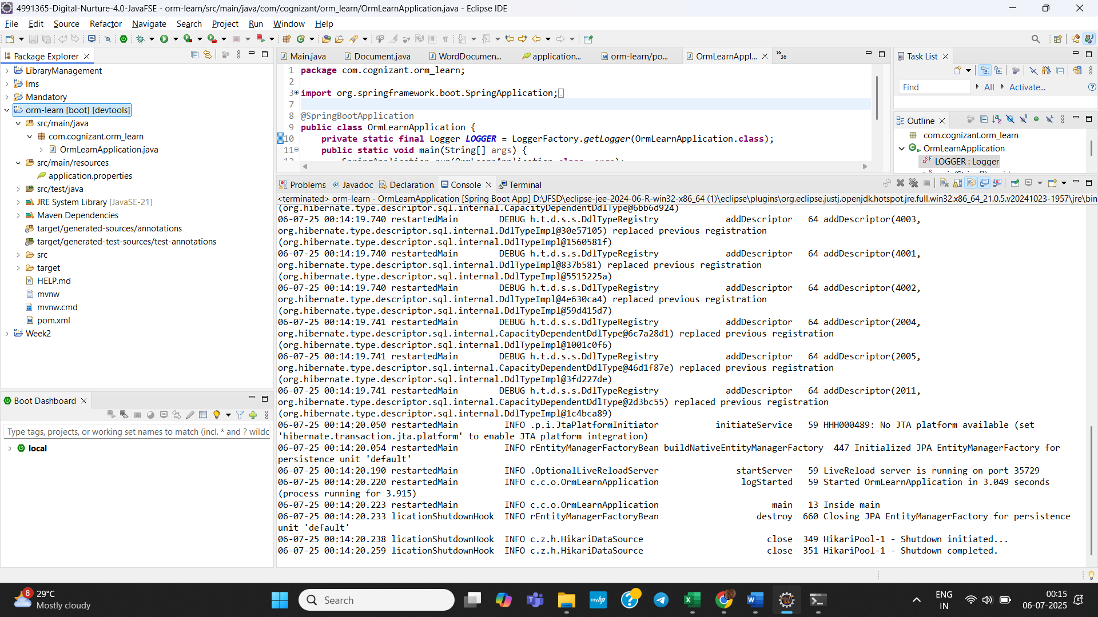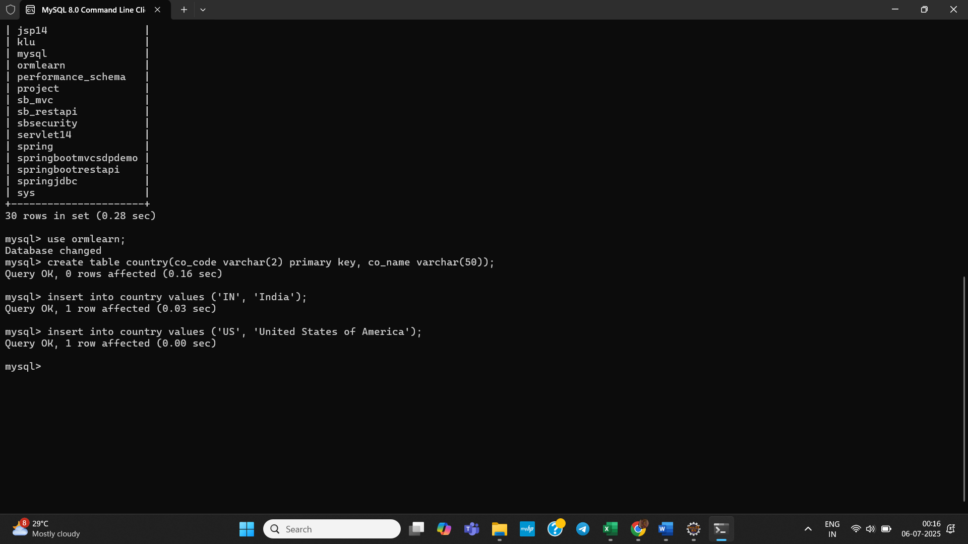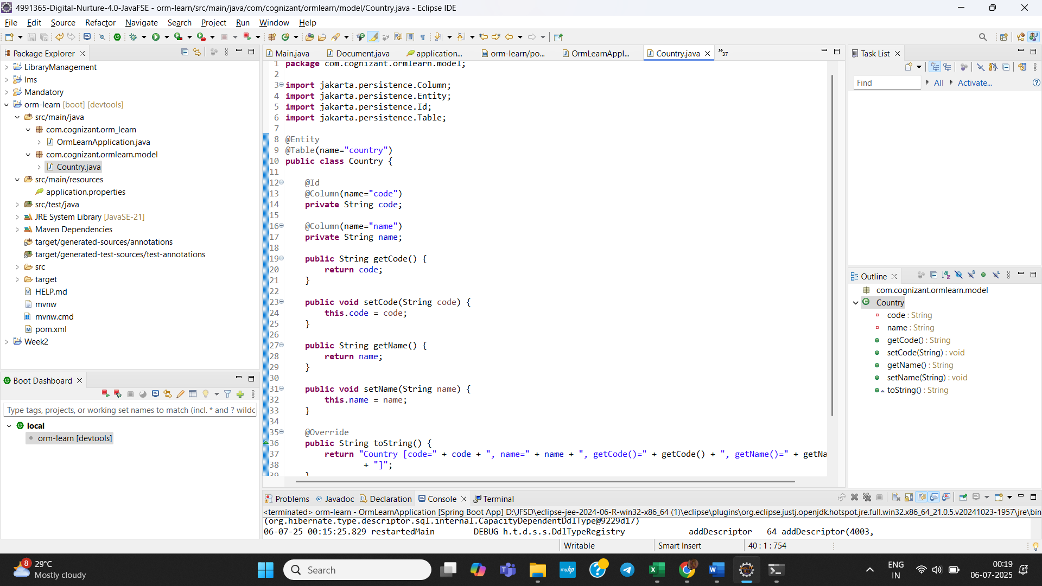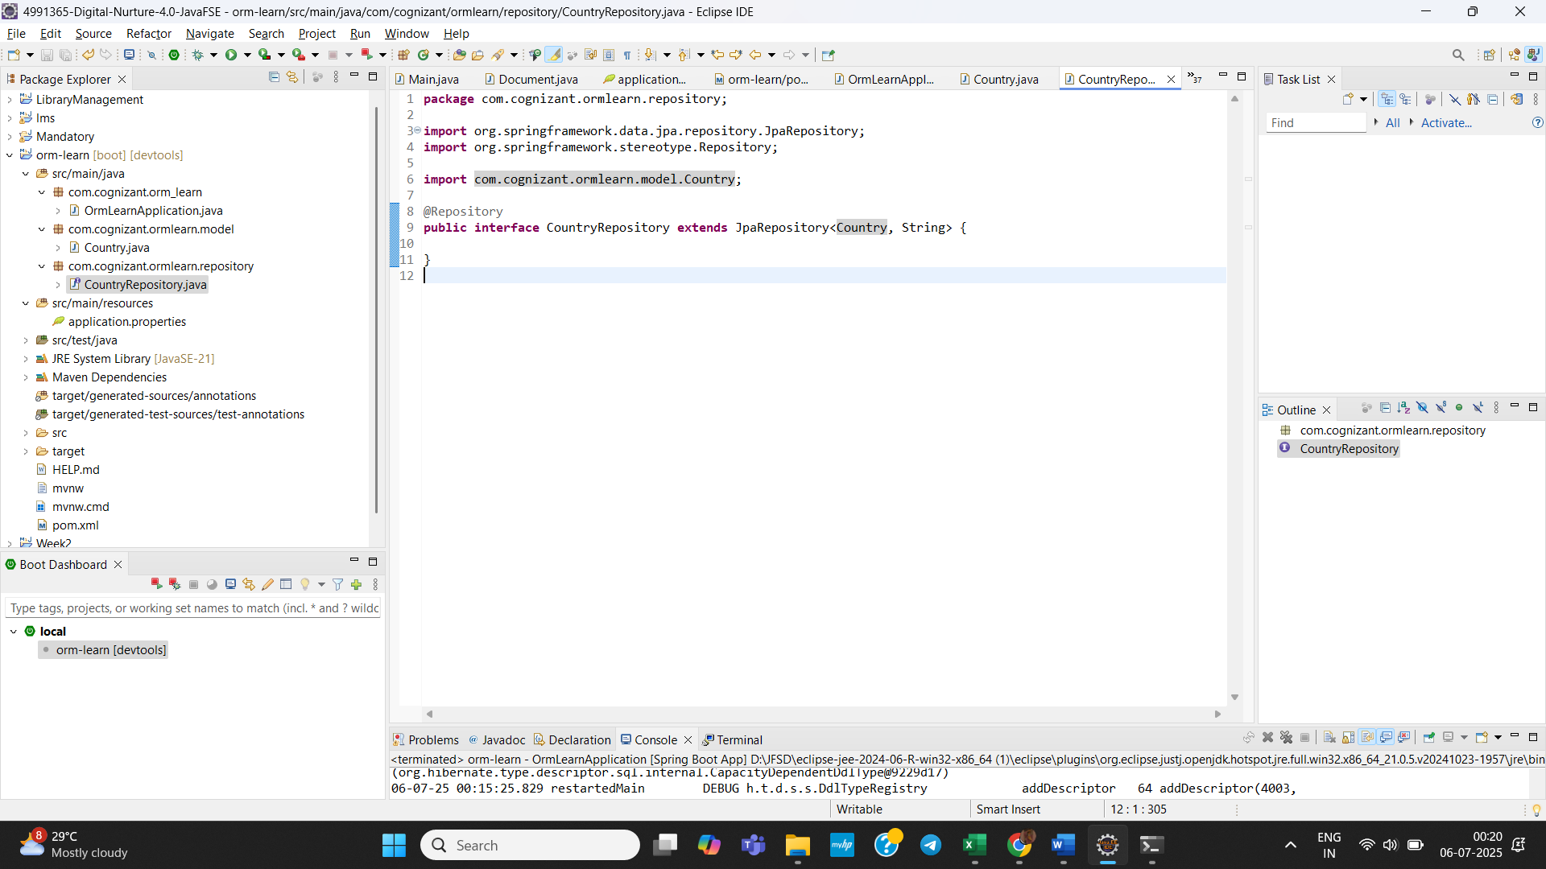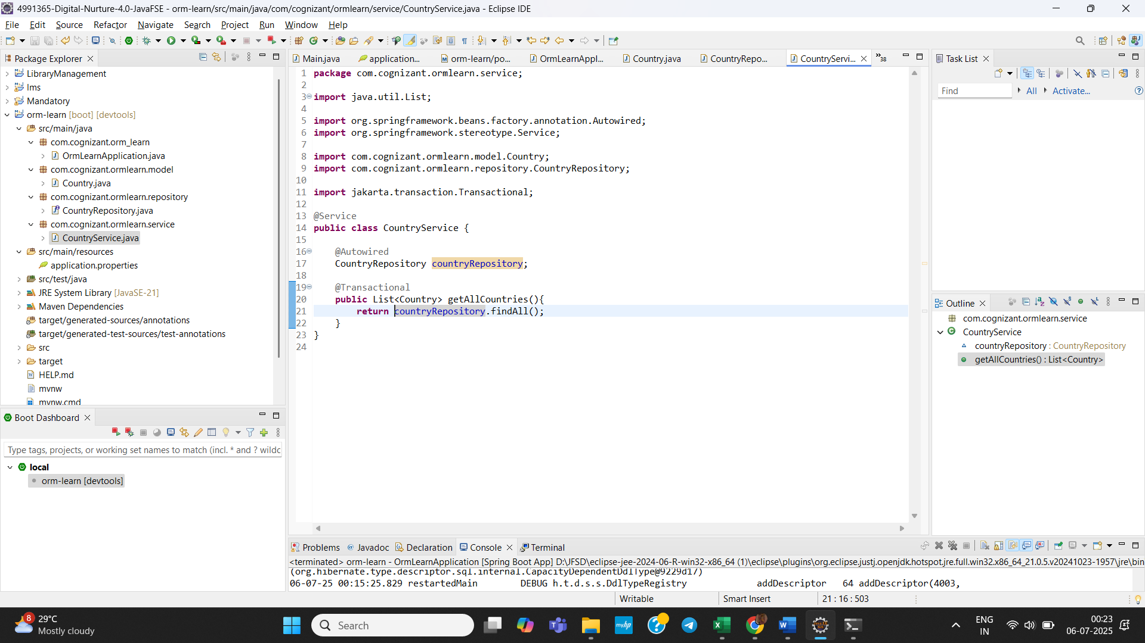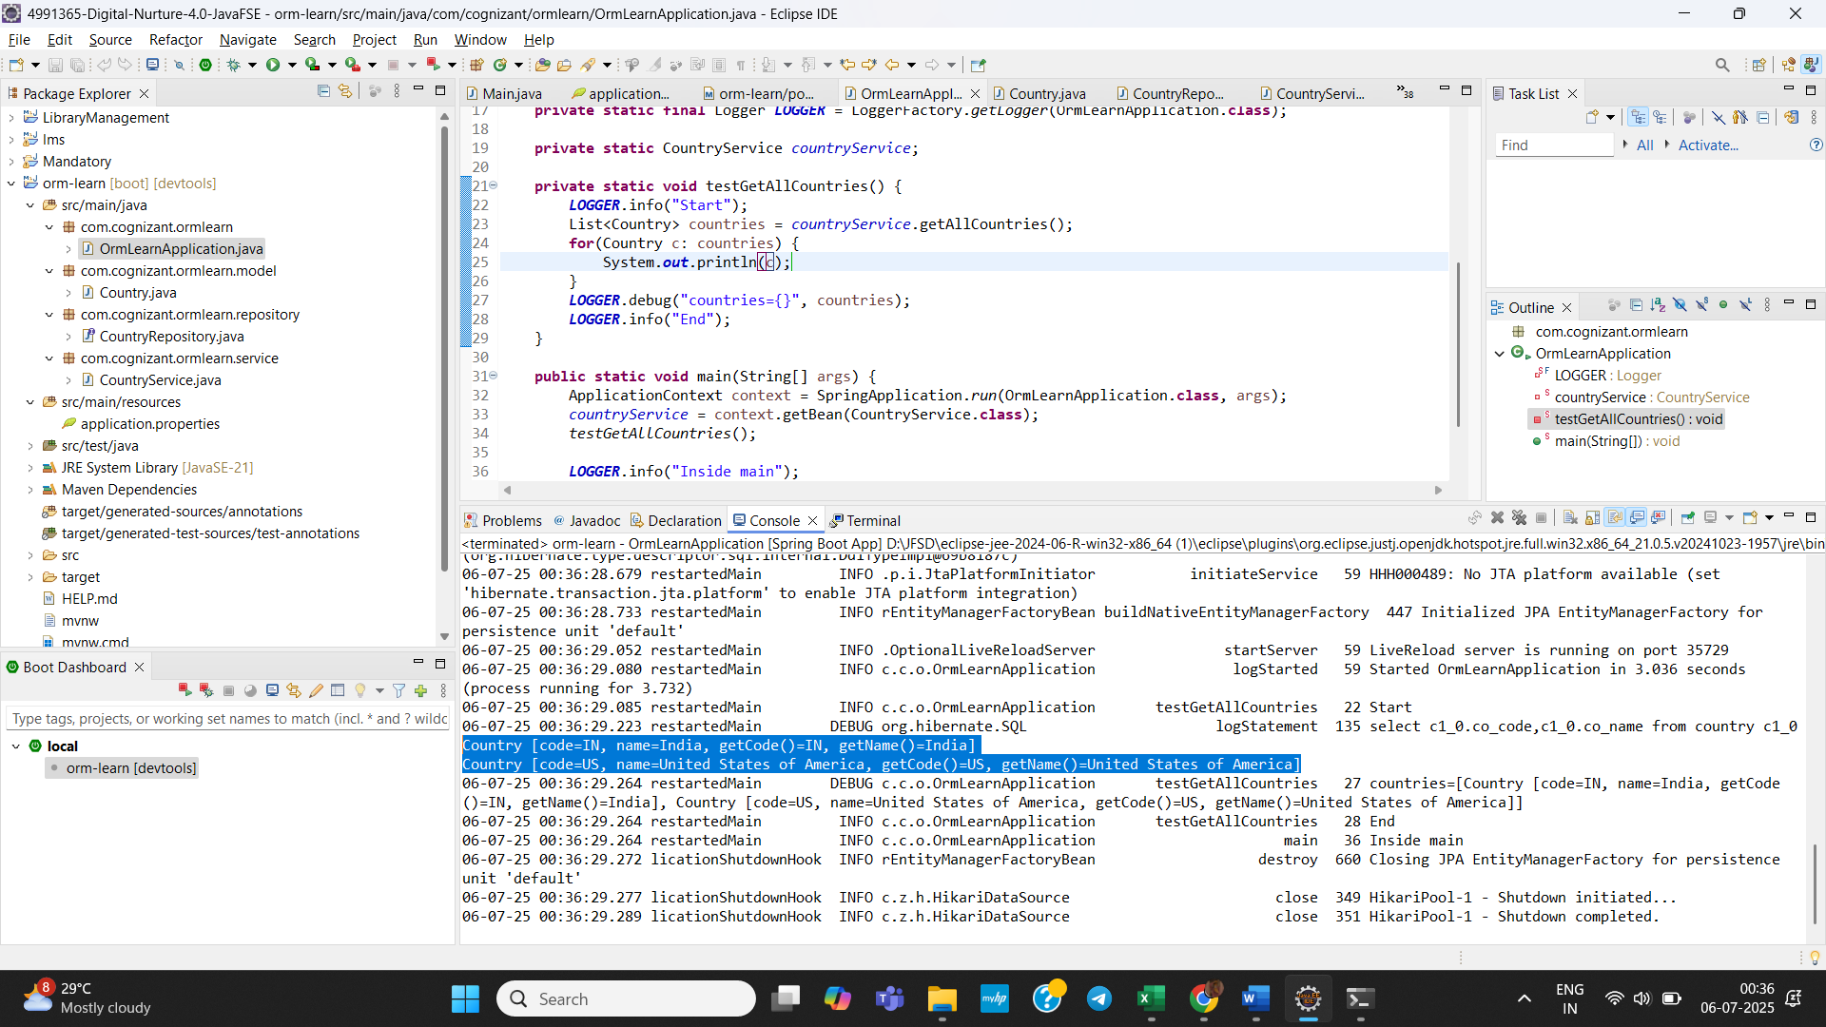

In Final Output, we retrieved the data from database.

- Difference between JPA, Hibernate and Spring Data JPA:

Java Persistence API (JPA):
- A specification (interface-only) for object-relational mapping (ORM) in Java.
- Contains only interfaces, annotations like @Entity, @Id, @OneToMany, etc.
- Does not include an implementation – it relies on providers like Hibernate or EclipseLink.

Hibernate :
- A concrete implementation of the JPA specification.
- Also includes its own APIs, like Session, Criteria, HQL (Hibernate Query Language).

Implementation :
public Integer addEmployee(Employee employee) {
Session session = factory.openSession();
Transaction tx = null;
Integer employeeID = null;

try {
tx = session.beginTransaction();
employeeID = (Integer) session.save(employee);
tx.commit();
} catch (HibernateException e) {
if (tx != null) tx.rollback();
e.printStackTrace();
} finally {
session.close();
}
return employeeID;
}

Spring Data JPA :
- A Spring-based abstraction on top of JPA providers (like Hibernate).
- Does not implement JPA but relies on providers like Hibernate.
- Removes boilerplate code.
EmployeeRepository.java:
public interface EmployeeRepository extends JpaRepository<Employee, Integer> {
}
EmployeeService.java:
@Autowired
private EmployeeRepository employeeRepository;

@Transactional
public void addEmployee(Employee employee) {
employeeRepository.save(employee);
}

